**Guided Capstone Project Report**

Ban Qu

The current price (i.e., weekend adult price) for Big Mountain is $81. First, to see how the current price fits the market, a model is trained inclusively with all other resorts other than Big Mountain. We used Random Forest regression to train the data as it performs better with cross-validation compared with linear regression. The result shows that the modelled price is $98.74, so even with a mean absolute error of $10.30, there is room for a price increase.

It is worthwhile to review the top features (i.e., features most likely to affect pricing) between Big Mountain and other resorts so that we would know where our resort sits in the market. Histograms are used for better visualizations. Overall, our resort compares very well for most important features. For instance, Big Mountain is among the top resorts with high vertical drop, or vertical change in elevation from the summit to the base (*Figure 1*), snow making, or total area covered by snow making machines (*Figure 2*), total number of chair lifts (*Figure 3*), the number of fast six person chairs (*Figure 4*), the number of runs (*Figure 5*), length of the longest run (*Figure 6*), and total skiable area (*Figure 7*).

With the options provided for discussion, I have the following recommendations to the board. First, regarding how many runs should be closed, the optimized number based on the model is 2 runs; closing 2 and 3 runs successively reduces support for ticket price and so revenue (*Figure 8*). From the illustration, increasing the runs over 6 will lead to a huge drop in ticket price and revenue. I would suggest that the business could start to close 2 runs and see how it affects the number of visitors and thus adjusting the ticket price. If doing well, the company may continue to close 1 and 2 more runs, respectively, to test for pricing. However, it should not close more than 5 runs based on the model. Second, if the resort is increasing the vertical drop by 150 ft, adding one run, with an additional chairlift, the support for ticket price will increase by $1.88, and revenue by around 3.3 million over the season. This option is highly recommended based on the profits it will bring as well as the fact that vertical drop is the top influential feature on pricing among all resorts. In fact, the company may consider increase vertical drop even further (e.g., by 200 feet or 250 feet) in the future to see the effect on pricing and revenue. Third, adding 2 acres of snow on top of the previous scenario has no effect on both ticket price and revenue, and therefore it is not recommended for the business. In addition, there will be no effect on ticket price and revenue if we increase the longest run by 0.2 miles and adding 4 acres of snow making. Therefore, the last option should be omitted from the discussion.

For further suggestions, the company may consider how adding/dropping the number of fast quads would affect the number of visitors and ticket price. Since most resorts have no fast quads, and fast quads is among the top influential variables, I would recommend another modelling scenario in the future regarding adding or dropping fast quads. If adding or dropping 1 or 2 fast quads has no makable impact on ticket price and revenue, the company might need to consider dropping fast quads to cut related expenses.

In sum, to increase pricing for a better revenue, as starters, Big Mountain could start to close 2 runs and increase the vertical drop by adding a run from 150 feet lower down with an additional chair lift. Based on the progress and results, the business could start to test on secondary options to further increase pricing, such as further increasing the vertical drop, closing more runs up to 5 (based on the usage frequency), and adding/dropping fast quads.

***Figure 1***

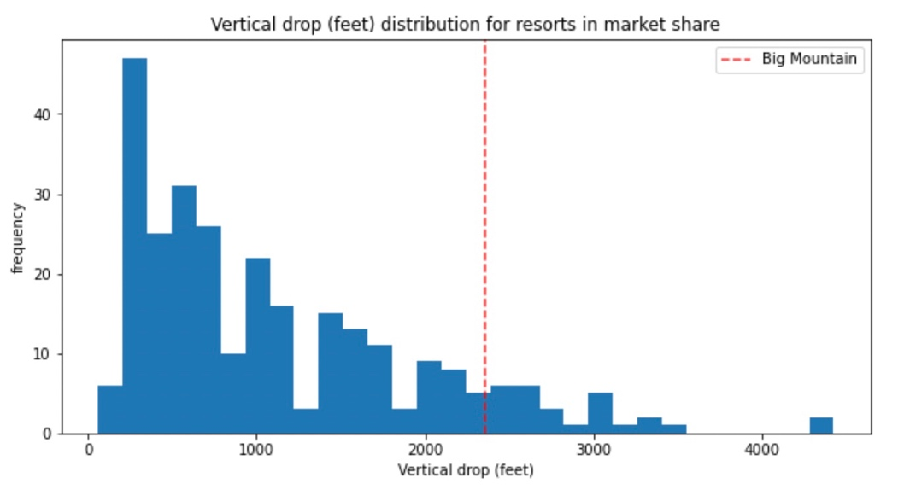

***Figure 2***

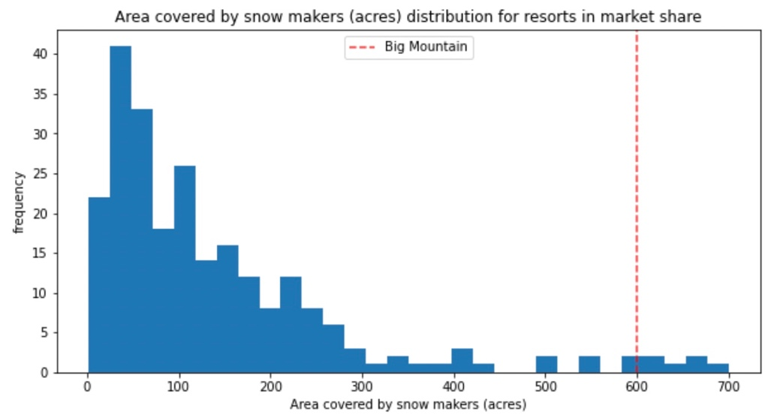

***Figure 3***

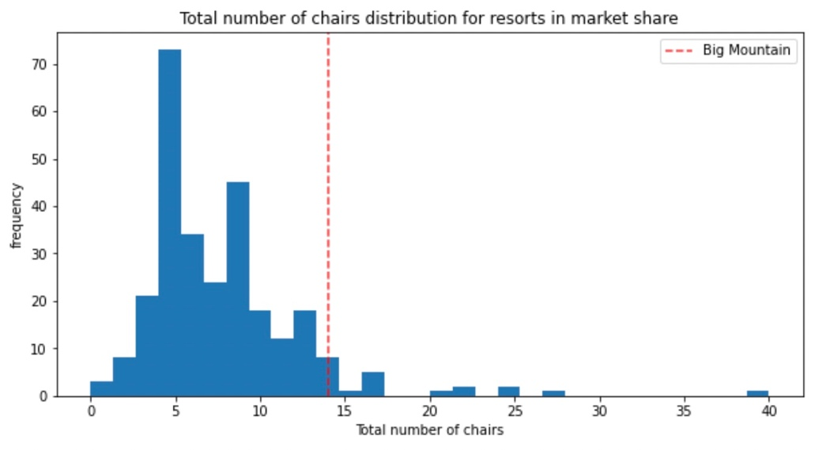

***Figure 4***

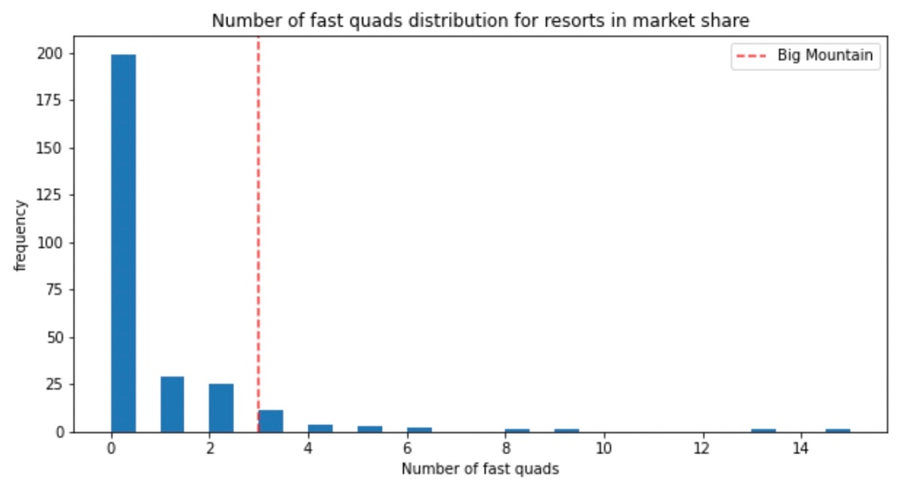

***Figure 5***

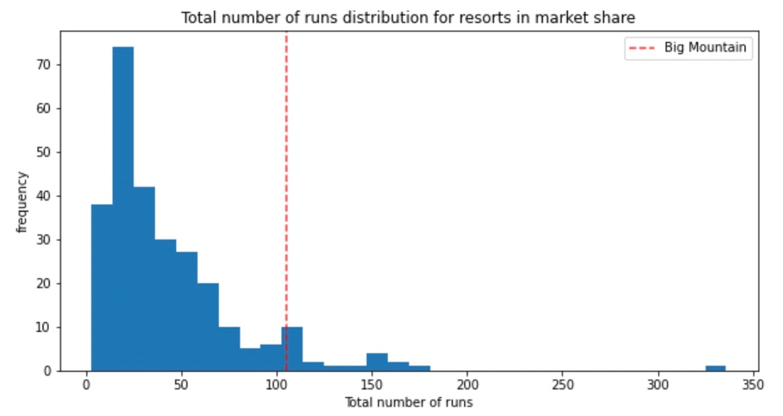

***Figure 6***

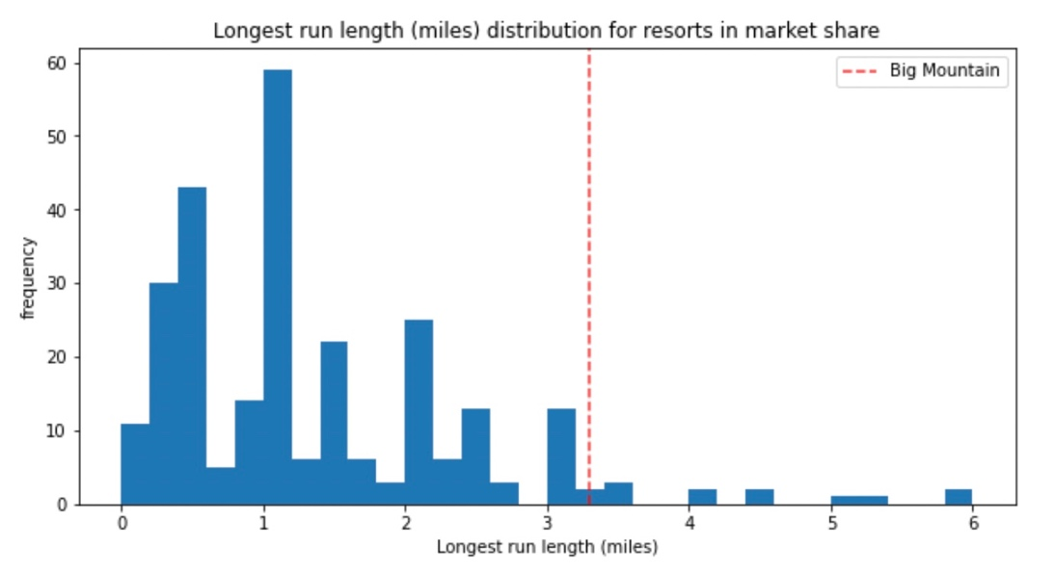

***Figure 7***

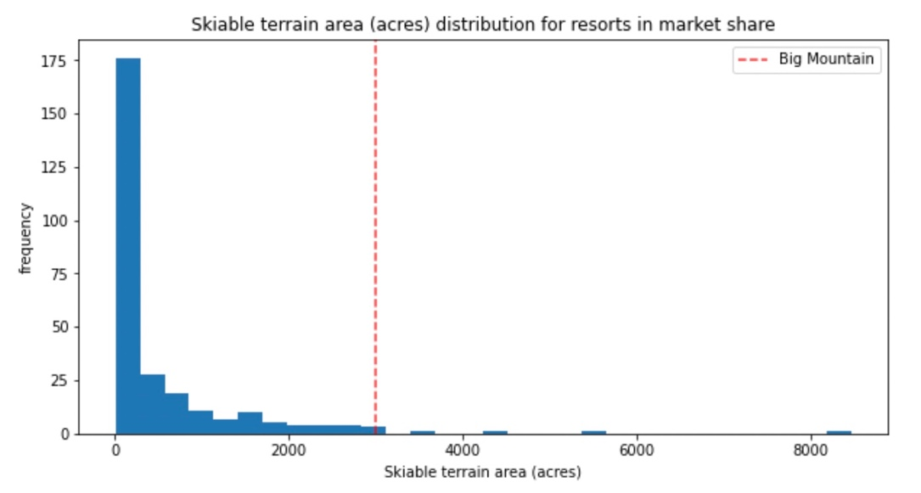

***Figure 8***

